[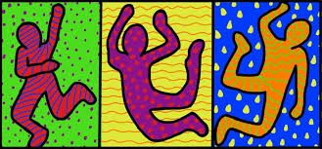](http://www.google.co.uk/url?sa=i&rct=j&q=&esrc=s&source=images&cd=&cad=rja&uact=8&ved=0ahUKEwi3huHlyp_WAhUFL8AKHTo4C_YQjRwIBw&url=http://drydenart.weebly.com/fugleblog/category/negative-space&psig=AFQjCNEyu_5VsUYF6inbR5pVgeOgZLCpvw&ust=1505303528092434)